Critical Care

Advanced Haemodynamic Monitoring

|  |  |
| --- | --- |
| **Title: Advanced Haemodynamic Monitoring** | **Authors: Duncan Stickle, Gill MacLean, David Hall, Stuart Gillon, Jen Service, Murray Blackstock** |
| **Status: Final** | **Approved by: QIT** |
| **Written: July 2022** |  |
| **Revised** | **Next Review: July 2025** |

Background 3

Indications for Echocardiography and Advanced Haemodynamic Monitoring 4

Echocardiography 5

Focused Echocardiography 5

Comprehensive Echocardiography 5

Trans-Oesophageal Echocardiography 5

Accessing Comprehensive and Trans-oesophageal Echocardiography 5

Advanced Haemodynamic Monitors 7

Selection 7

Pulse contour analysis 8

FloTrac - Uncalibrated Pulse Contour Analysis 8

VolumeView - Calibrated Pulse Contour Analysis (Transpulmonary Thermodilution) 10

Pulmonary Artery Catheter 13

Interpretation & Normal Values 16

# Background

Cardiovascular dysfunction is the most common reason for admission to critical care in the United Kingdom. All patients admitted for support of their circulation will have an arterial line placed; the vast majority will also have a central venous catheter.

Assessment and monitoring of the cardiovascular system will involve a combination of:

|  |  |
| --- | --- |
|  | Examples |
| ***Clinical assessment*** | Peripheral perfusion  Capillary refill  Mentation  Urine output |
| ***Routine Haemodynamic Monitoring*** | Invasive arterial blood pressure  Central venous pressure  ECG |
| ***Biochemical parameters*** | Arterial lactate  Central venous oxygen saturation  Markers of end organ perfusion   * Renal function * Liver function |
| ***Echocardiography*** | Focused transthoracic echo   * Binary questions related to haemodynamic state   Diagnostic transthoracic echo   * Diagnostic study including quantification of systolic function, assessment of valves, assessment of diastolic function.   Transoesophageal echo |
| ***Advanced Haemodynamic Monitoring*** | Quantification of stroke volume and cardiac output  Static and dynamic markers of preload  Derivation of vascular resistance.  Right heart and pulmonary artery pressure measurement |

# Indications for Echocardiography and Advanced Haemodynamic Monitoring

Consider echocardiography and use of advanced haemodynamic monitoring in the following situations:

* **Shock that is refractory to initial management**
  + i.e. haemodynamic parameters and markers of end organ perfusion do not improve with initial management (fluid replacement, initiation of vasopressors, normalization of heart rate etc)
* **High doses of vasoactive medications**
  + e.g., >20ml/hr of noradrenaline (8mg%; “single strength”)
  + e.g., second vasopressor medication required
* **Suspected or known haemodynamic complexity**
  + Primary cardiac disease (acute ischaemia, cardiomyopathy, valvular heart disease, right ventricular failure)
  + Recent cardiac or aortic surgery
  + Pulmonary hypertension

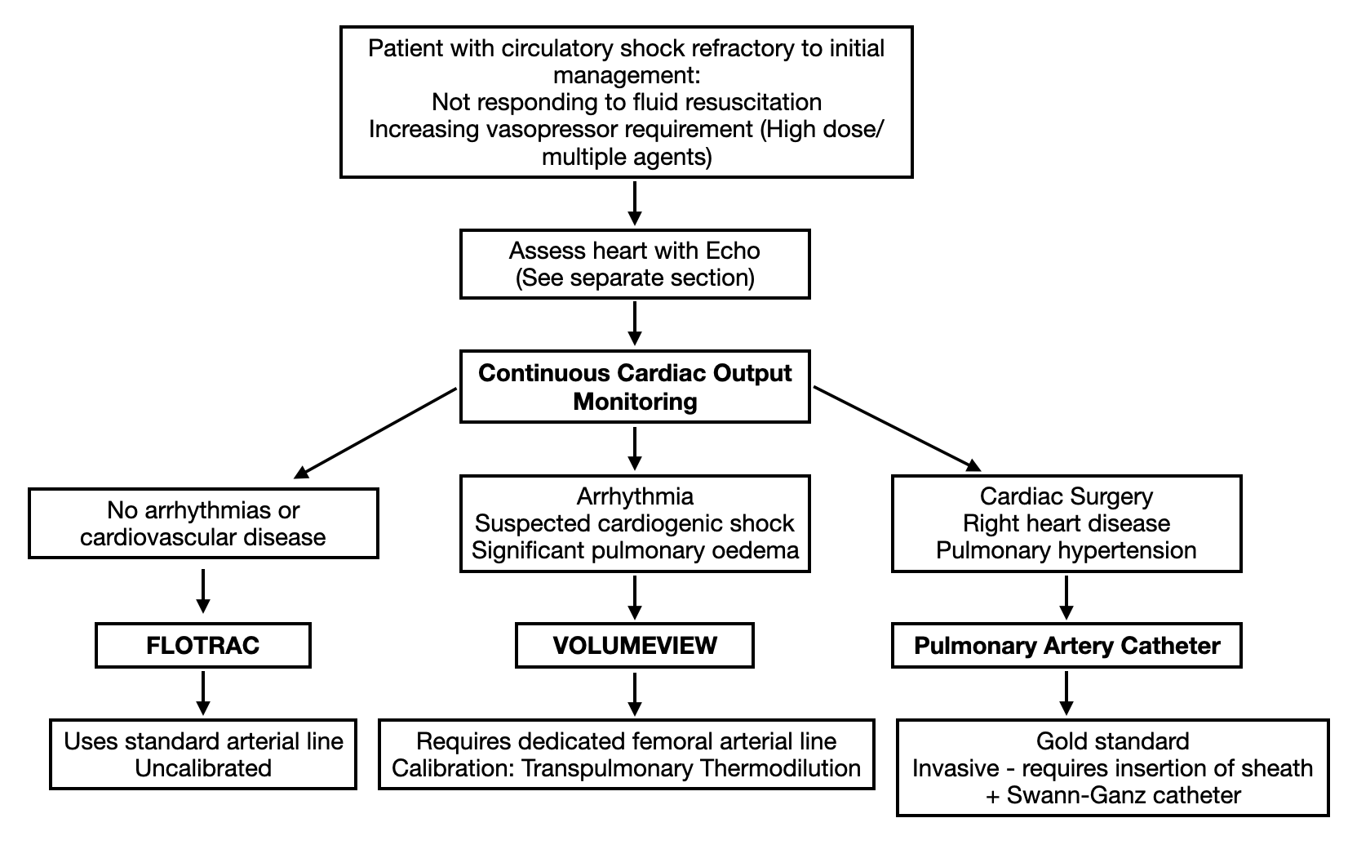

# Echocardiography

Echocardiography offers a rapid, non-invasive means or initial assessment of the shocked patient.

## Focused Echocardiography

Many ICM consultants/registrars can carry out basic transthoracic echo following accreditation through the FUSIC or other focused echo training programs These focused studies will assess for significant ventricular impairment or dilation, pleural or pericardial effusion and signs of reduced venous return.

Focused echocardiography can only identify markedly abnormal findings. If there is any question of cardiac pathology a comprehensive echo should also be organized.

Focused echo does not allow for continuous monitoring of haemodynamics and the additional use of advanced haemodynamic monitoring should be considered if cardiovascular instability persists following initial intervention, or if cardiovascular support requirements are high.

## Comprehensive Echocardiography

Comprehensive transthoracic echo assessment can provide more detailed assessment of shock, including quantification of systolic and diastolic function, assessment of valves, and assessment of the haemodynamic effects of pericardial fluid.

Repeated comprehensive scans will allow for trending of these variables for comparison

For assessment of LV function with equivocal image quality, LV contrast studies can be requested and performed using the 118/16 GE Vivid S70N ultrasound machine.

## Trans-Oesophageal Echocardiography

Occasionally required in cases with suboptimal TTE images and ongoing diagnostic uncertainty

Specific indications:

* + Clinical suspicion of endocarditis (e.g. persistent bacteraemia with no clear source) with normal or equivocal transthoracic echo
  + Suspicion of intra-cardiac abscess (typically in the present of aortic valve endocarditis)
  + Severe valvular pathology causing critical illness, in order to inform need for surgical intervention
  + Suspected aortic dissection
  + Recent cardiac/aortic surgery

## Accessing Echocardiography in NHS Lothian Critical Care

**FICE/FUSIC**

* In all units, many critical care consultants or registrars and some ACCPs can preform FICE/FUSIC scans.

**Comprehensive Transthoracic echocardiography**

* In-house full studies can be carried out by specific ICM consultants who have further qualifications in echocardiography: Dave Hall, Mike Gillies, Murray Blackstock

*Royal Infirmary*

* In hours: request to sonographers via Trak for comprehensive transthoracic scan (with phone call to 21814/21813 if urgent)
* Out of hours: Cardiology SpR (Page #4028)

*St John’s Hospital*

* In hours contact 53851
* Out of hours – no on-site provision. Contact cardiology at RIE if out of hours scan deemed necessary.

*Western General Hospital*

* In hours via paper request and phone 31852
* Out of hours - no on-site provision. Contact cardiology at RIE if out of hours scan deemed necessary.

**Transoesophageal Echo**

* Transoesophageal echo can be organized via the cardiology registrar or consultant;
* Urgent TOE support at RIE can be requested from cardiothoracic anaesthesia.
* 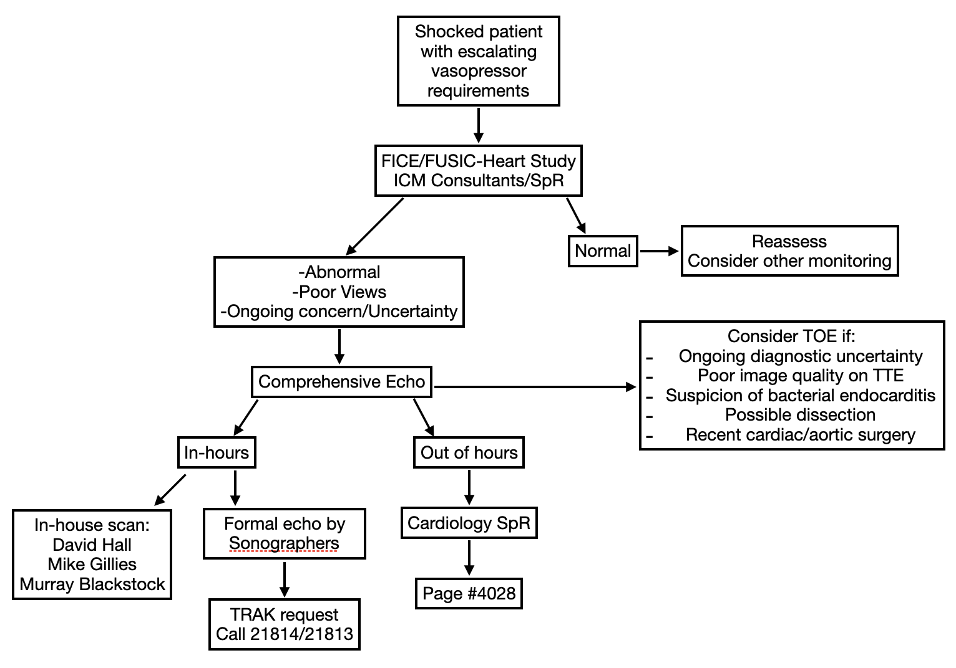

# Advanced Haemodynamic Monitors

## Selection

|  | Advantages | Disadvantages | Useful scenarios |
| --- | --- | --- | --- |
| Uncalibrated Pulse Contour Analysis (Flowtrac) | Easy to set up  No calibration  Uses normal arterial line  Continuous data | Uncalibrated therefore absolute values less reliable  Provides more limited variables/information  Not usable in arrhythmia | First line for continuous CO monitoring |
| Transpulmonary thermodilution (VolumeView) | Calibration allows for more reliable absolute measurements  Continuous data  Provides extra variables | Requires frequent recalibration  Necessitates insertion of new invasive femoral line  Most accurate measurements when the CVC is in the jugular or subclavian veins. | Patients for whom uncalibrated PCA is unsuitable eg. arrhythmias, aortic valve disease  Patients whose treatment may benefit from the extra variables (GEDV, EVLW, ITBV) |
| Pulmonary artery catheterisation | Gold standard  Direct assessment  Provides extra variables (RA, PA and wedge pressures)  Useful in right heart dysfunction | Invasive - large catheter  Higher risk of complications  Continuous | Post cardiac surgery  Right heart dysfunction  Pulmonary hypertension  Patients whose treatment may benefit from the extra variables (PAOP, PAP etc.)  Presence of an Intra-aortic Balloon Pump |
| Echocardiography | Fast  Non-invasive  Can be used to identify pathology/causes for instability, assess cardiac function & guide management | Dependent upon a skilled operator  Snapshot, intermittent | Initial assessment  Guiding management eg. inotropy |

## Pulse contour analysis

Based on principle that stroke volume is proportional to arterial pulse pressure - analyses arterial pulse waveform using a specialist transducer and derives stroke volume, cardiac output and systemic vascular resistance.

## FloTrac - Uncalibrated Pulse Contour Analysis

Normal radial arterial line

No calibration - utilises patient demographic data - age, gender, BP, calculated body surface area

Proprietary algorithms analyses arterial waveform (area under curve) in order to calculate cardiac output

* PRO
  + Easy to set up - no additional lines required, can use normal radial arterial line
  + Provides information on commonly used variables (see section 6 below)
    - **Stroke volume**
    - **Cardiac Output**
    - **Cardiac Index**
    - **Stroke Volume Variation**
* CON
  + Uncalibrated - Not reliable in arrhythmias, aortic stenosis/regurgitation
  + Requires good quality, non-dampened waveform
  + Do not provide all variables available from other more invasive modes of monitoring
  + Some evidence that absolute values may not correlate with thermodilution measurements via PAC - may be more useful for monitoring **trends**

**Contents of Box:**

* FloTrac Transducer
* Single transducer cable
* 1L 0.9% NaCl
* Pressure bag

**Setup Guides:**

Edwards LifeSciences guide: <https://edwardsprod.blob.core.windows.net/media/Gb/devices/monitoring/hemodynamic%20monitoring/ar07457-flotrac_ev1000_setupguide_1251alrip.pdf>

Setup Video link: <https://www.youtube.com/watch?v=I6N1nxkz_iY&ab_channel=EdwardsLifesciencesClinicalEducation>

**Step by step:**

1. Prime line and sensor with NaCl
2. Inflate to 300mmHg
3. Attach to arterial line
4. Attach cables from transducer:
   1. Red to red single transducer cable to bedside monitor
   2. Green to green Flowtrac monitor cable
5. Enter demographic information on monitor for calibration
6. Zero EV1000 monitor and bedside monitors

## VolumeView - Calibrated Pulse Contour Analysis (Transpulmonary Thermodilution)

* Injection of cold injectate via CVC
  + Thermistor placed in femoral artery detects changes in blood temperature
  + Rate of blood flow inversely proportional to change in temperature over time - used to measure cardiac output
* Generally good correlation with measurements from PAC
* Used to calibrate pulse contour analysis to then allow continuous measurements
  + Requires semi frequent (1-4h or change in circulatory status) recalibration
* Allows measurement of extra variables:
  + **Global end-diastolic volume (GEDV)**
  + **Intrathoracic blood volume (ITBV**)
  + **Extravascular lung water (EVLW)**

**Contents of box:**

* Femoral arterial catheter kit
* Venous injectate kit - Thermistor manifold
* Volumeview transducer
* Single transducer cable
* 1L 0.9% NaCl
* Pressure bag

**Setup Guides:**

(Intranet): <https://critcare.net/1a74f8f7b8b7e871b413c4697f68b4401fbacdf0/criticalcare/Cardiovascular/Cardiac%20Output%20Monitor%20VolumeView%20Setup.pdf>

<https://edwardsprod.blob.core.windows.net/media/Gb/devices/monitoring/hemodynamic%20monitoring/ar07460.pdf>

Setup Video: <https://www.youtube.com/watch?v=IxuOTZPkPbw&ab_channel=EdwardsLifesciencesClinicalEducation>

[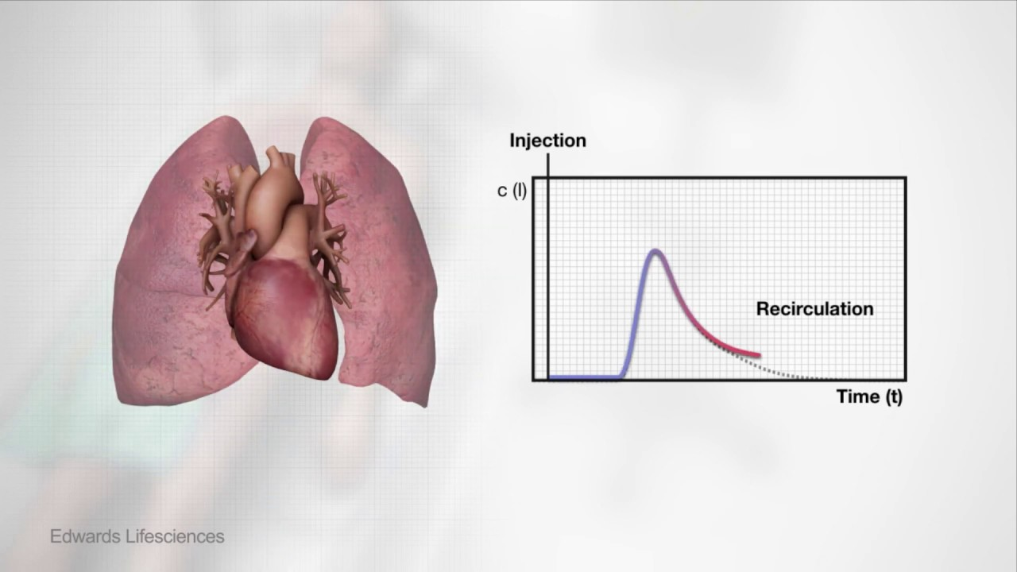](https://www.youtube.com/watch?v=IxuOTZPkPbw)

**Step by step**

1. Insert CVC
2. Insert VolumeView femoral arterial catheter
3. Attach TruWave CVP monitor to CVC via thermistor manifold
   1. Flush manifold with saline, attach to any line of CVC
   2. Attach in-line thermistor cable to manifold connection
   3. Attach CVC transducer tubing to side port
   4. End port is left for TPTD
4. Attach cables to databox
   1. Green trifurcated pressure cable to green/blue “CO/CVP” port
   2. Black thermistor cable to black “TD” port
5. Mount VolumeView sensor + CVP transducer to databox
6. Remove and discard fluid administration set from VolumeView sensor
   1. Replace by attaching free connection from TruWave CVP transducer
7. Attach flush bag and prime tubing to both sensor and transducer
8. Connect VolumeView sensor pressure tubing to femoral arterial line
9. Attach cables
   1. Green pressure cable to green VolumeView monitor cable
   2. Truwave CVP transducer to Blue VolumeView monitor cable
   3. Red VolumeView cable to bedside monitor arterial transducer cable
   4. Blue/White VolumeView cable to bedside monitor CVP transducer cable
   5. Thermistor cable (bifurcated) to femoral arterial line (red) and thermistor manifold (black)
10. Zero bedside monitor and EV1000 monitor for CVP and arterial pressure channels
11. Perform transpulmonary thermodilution as per manufacturer instructions (See guide on intranet) - May need more detail
    1. Touch “clinical actions” then “thermodilution”
    2. Select injectate volume and define any lung resection
    3. Touch “Start Set”
    4. Attach pre-filled syringe (Usually 15-20mls 0.9% NaCl, at minimum temp 15 degrees celsius)
    5. Inject in single smooth motion when prompted on screen
    6. Repeat steps 4 & 5 above for a total of 3-6 injections
    7. Review boluses; touch “accept”
12. System will now be calibrated for displaying and trending continuous variables

## Pulmonary Artery Catheter

Measures cardiac output by **Pulmonary Thermodilution** - Heating element in catheter, thermistor at tip. CO calculated similarly to trans pulmonary thermodilution using Hamilton-Stewart equation

Considered **gold standard** for cardiac output

Allows direct measurement of important additional variables:

* RA pressure
* PA pressure
* PA occlusion/wedge pressure
  + Wedging in pulmonary artery creates column of blood which equilibrates with downstream pressure ie LA pressure, which approximates LVEDP, an indicator of LVEDV (Preload)
* More invasive, more complications
  + 8fr catheter - CI in coagulopathy
  + Complications include: Bleeding, arrhythmias, infection, pulmonary infarction, PA rupture, valve damage

**Indications**: Right heart dysfunction, pulmonary hypertension, recent cardiac surgery

**Contraindications**: pulmonary/tricuspid valve prosthesis (or severe stenosis), endocarditis/vegetations, right heart mass, thin/delicate wall

**Contents of box**

* Hemosphere Swann-ganz module
* Patient CCO cable
* Swann-ganz catheter

**Setup (Needs completion)**

Edwards LifeSciences guide (Intranet): <https://critcare.net/1a74f8f7b8b7e871b413c4697f68b4401fbacdf0/criticalcare/Cardiovascular/Cardiac%20Output%20Monitor%20HemoSphere%20Setup_pub.pdf>

Video: <https://www.youtube.com/watch?v=FsBlwic0FZw&ab_channel=EdwardsLifesciencesClinicalEducation>

[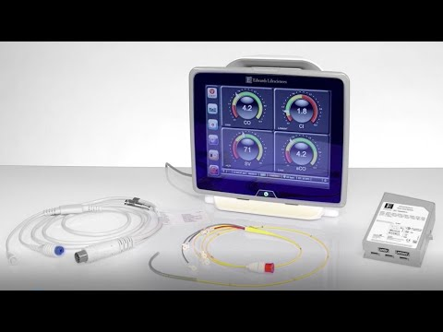](https://www.youtube.com/watch?v=FsBlwic0FZw)

# Interpretation & Normal Values

All taken from Edwards Lifesciences guide: <https://critcare.net/1a74f8f7b8b7e871b413c4697f68b4401fbacdf0/criticalcare/Cardiovascular/Cardiac%20Output%20Monitor%20Normal%20Values.pdf>

| Variable | Normal Range | Notes |
| --- | --- | --- |
| Stroke Volume (SV) | 60-100ml | Volume ejected by LV in single cardiac cycle |
| Stroke Volume Index (SVI) | 33-47ml | SV indexed to body surface area |
| Cardiac Output (CO) | 4-8L/min | SV x HR |
| Cardiac Index (CI) | 2.5-4L/min/m2 | CO indexed to body surface area |
| Stroke Volume Variation (SVV) | 10-15% | Changes in stroke volume over respiratory cycle. Higher variation suggests fluid responsiveness/hypovolaemia |
| Systemic Vascular Resistance (SVR) | 800-1200 dyn/sec/cm-5 | Resistance to blood flow to be overcome |
| Systemic Vascular Resistance Index (SVRI) | 1970-2390 dyn/sec/cm-5/m2 | SVR indexed to body surface area |
| Central Venous Pressure (CVP) | 2-6mmHg |  |
|  |  |  |
| Global End Diastolic Volume Index (GEDI) | 650-800ml/kg | Filling volume of all 4 heart chambers (indexed to body surface area) |
| Intrathoracic Blood Volume Index (ITBI) | 850-1000ml/m2 | Filling volume of 4 heart chambers + pulmonary circulation (indexed to body surface area) |
| Extravascular Lung Water Index (ELWI) | 0-7ml/kg | Quantification of lung oedema (not including effusions) - indexed to body surface area |
|  |  |  |
| Pulmonary Artery Pressure (PAP) | 15-25mmHg (Systolic)  8-15mmHg (Diastolic) | PAC |
| Right Ventricular Pressure (RVP) | 15-25mmHg (Systolic)  0-8mmHg (Diastolic) | PAC |
| Pulmonary Artery Occlusion Pressure (PAOP) (Wedge) | 6-12mmHg | PAC - estimation of LVEDP |
| Pulmonary Vascular Resistance (PVR) | <250 dyn/sec/cm-5 | PAC |
| Pulmonary Vascular Resistance Index (PVRI) | 255-285 dyn/sec/cm-5/m2 | PAC |